**CS3354 Software Engineering**

**Final Project Deliverable 2**

Nibiru

Justin Holloway

Jin Chen

Duy Truong

Kristofer Sanchez

Paul Thang

Hongyun Du

Tze Yang Chen

Table of Contents

Final Project Description 3

Title 3

Group Members 3

Purpose 3

Description 3

Tasks (Each member assigned at least 3 different tasks) 4

Previous Draft and Feedback 5

GitHub Repository 6

Delegation of Tasks 6

Project Deliverable Document 6

GitHub Creation/Initial Commits 6

Software Process Model 6

Software Functional & Non-Functional Requirements 6

Use Case Diagrams 6

Sequence Diagram 6

Class Diagram 6

Architectural Design 6

Software Process Model 6

Software Functional and Non-Functional Requirements 7

Use Case Diagram 8

Sequence Diagram 9

Creating an Account 9

Message Other User 9

Search Other Accounts for Items 10

View Other Users 11

Accept Transaction Offer 12

Customize Profile 13

Make an Offer On an Item 14

Rate a Transaction 15

Class Diagram 16

Architectural Design 17

# Final Project Description

### Title

**Nibiru:** Musician’s equipment community and exchange application

### Group Members

Justin Holloway

Jin Chen

Duy Truong

Kristofer Sanchez

Paul Thang

Hongyun Du

Tze Yang Chen

### Purpose

This project will serve the purpose of designing a PC application intended for musicians looking to share and exchange equipment with users of similar genres, specs, experience, etc. The main feature of the software will be the ability to create a profile containing information about current equipment within a users setup. With this data, other user’s will be able to view this profile and view the instruments and other components that may be of interest to them. This is different from other services that are currently available. Our goal is to combined multiple available services into one friendly location/application. Service such as eBay and Craigslist provide online personal retail, but what they do not do is ensure authentic equipment is being sold, it is essentially an unverified open market which is great but not for a customer who is looking for a specific sound or functionality from an instrument. Additionally, the profile owner may post demos of their work using the specified equipment they have listed, this function is not currently available on any online sales platform. From there, they can make the viewing users an offer on the equipment if they are interested in purchasing it. If no sale is offered, then this stage can be replaced by showing purchase options for the equipment at local retailers instead. Another component of the application will be the ability for businesses to post shows that they will be hosting. Local users will be able to see this posting and offer to perform in that event. An equipment rental feature will also be included for both business accounts and users.

### Description

Our motivation is to change the relationship between the current instrument market and people. The central theme of most social software on the market today is the interaction between people. Our hope is to create a product that can use personal items to be the theme, thus driving the communication between those interested in this product. It is suitable for People with specific needs, or a group with a particular hobby for an item. For example, musicians have a hobby for musical instruments. Where to get more intuitive and professional information is crucial and not currently available all in one location. Traditional musical instrument sales are a purely commercial transaction between the buyer and the seller. These transactions usually take place in a brick and mortar store which is great, but not for those who do not have access to these stores. The goal of this software is to change this structure, joining the interaction between the buyer and the seller. This application will let the transaction itself become an interaction with the music and discuss the topic of the instrument itself.

Every day, hundreds of music albums are released globally, people are going to buy those albums and enjoy the music. We will add a feature to make a connection between the music and the instruments the musician used in making the music. The software will allow professional-level buyers to have a more informative sharing and shopping experience. For example, a musician participated in the production of a specific song. The musician then posted the instrument and connected it to the music, those who have heard the music and were impressed by the sound of the device/instrument are more likely to be a potential purchaser. This kind of shopping information will have a more accurate match value than the traditional text description. The software allows sellers to sell their instruments while also allowing people to pay attention to the music. For buyers, buying a guitar with a music album that improves their sound is also a new experience.

### Tasks (Each member assigned at least 3 different tasks)

1. Function Management

Tze-Yang Chen and Hongyun Du

1. Organization and workflow

Justin Holloway

1. Proof reading

Justin Holloway

1. UI / UX

Tze-Yang Chen and Jin Chen

1. Professor / TA communication

Kristofer Sanchez and Paul Thang

1. (Optional) implementation

All members

1. Presentation construction

All Members

1. Profits and cost

Justin Holloway, Jin Chen, Duy Truong, and Paul Thang

1. User communication

Hongyun Du

1. Logistics

Justin Holloway and Jin Chen

1. Functional / non-functional requirements

Kristofer Sanchez and Hongyun Du

1. Technical details

Duy Truong

1. File management (providing demo video files, demo mp3 files, etc. and backup files in cloud driver)

Tze-Yang Chen, Jin Chen, and Paul Thang

================================Below is deliverable 2===================================

1. Project Scheduling <include MS project>

Tze-Yang Chen Hongyun Du

1. Cost, Effort and Pricing Estimation <include hardware, software, and personnel>

Duy Truong, and Paul Thang

1. Test plan

Justin Holloway

1. Comparison of similar designs

Jin Chen

1. Implementation of the code

Hongyun Du

1. Migration of old file and all documenting

Kristofer Sanchez and Tze-Yang Chen

1. PowerPoint and conclusion

All members

================================Above is deliverable 2===================================

### Previous Draft and Feedback

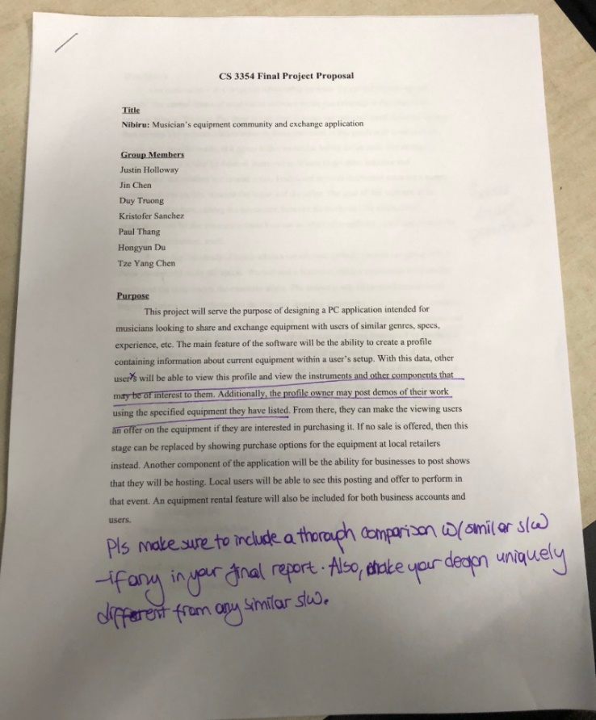

We address the feedback left by searching and analyzing what is currently available on the market. Currently we have sales services provided by eBay and Craigslist, and the likes. What these services do not provide is the ability to get first hand experience sales representatives, or access to subject matter experts. While they serve as a platform to sale music equipment they do not give an experience tailored to musicians. Nor is there the ability to find equipment you want based on sound, I can not go to any of these services and search for equipment based on a specific sound I am looking for in my music. The second aspect of our service is to provide opportunity for musicians and venues to find talent. This service is provided by MusicianCasting.com and can be done by websites like Monster and Indeed, but our goal is to bring the social aspect and sales aspect together in one location so there is no need to use multiple services.

# GitHub Repository

The following link is to the GitHub repository for Nibiru

https://github.com/KSanchez89/3354-Nibiru

# Delegation of Tasks

## Project Deliverable Document

Kristofer Sanchez

## GitHub Creation/Initial Commits

Kristofer Sanchez and Justin Holloway

## Software Process Model

Tze Yang Chen

## Software Functional & Non-Functional Requirements

Completed as team

## Use Case Diagrams

Justin Holloway and Paul Thang

## Sequence Diagram

Hongyun Du and Jin Chen

## Class Diagram

Duy Truong

## Architectural Design

Tze Yang Chen

# Software Process Model

The software process model we will use for Nibiru is an Evolutionary Model more specifically Prototyping. The reasons are as follows. First, we are making a complex software. To implement different functions, our team often needs to spend time together to discuss and research whether these functions can meet the needs of users. Secondly, our time is limited, we need to design and build a software framework in a short period. We need to quickly categorize the functionality of the software through rapid design. In addition, we need to gradually study and discuss specific software features, as well as to maximize the functionality of the software and the needs of users who actually use it. Finally, in this design environment, we need to use a lot of iterative processes in the development and design process to gradually implement more complex functions on the basic functions.

# Software Functional and Non-Functional Requirements

The following table lists the functional and non-functional requirements for Nibiru.

|  |  |
| --- | --- |
| **Non-Functional** | **Functional** |
| Performance Requirements:  Uploading speed of at least 1Mbps | Users must be able to direct message with other users. |
| Space requirements:  Website will have a backup of user accounts and transactions. | User may post comments to sellers product pages. |
| Accounting requirements:  Website will not retain/store user financial account information e.g. credit card numbers and bank information. | Seller may upload product pictures and descriptions. |
| Safety/security requirements:  User account passwords will be required to be 8 to 23 alphanumeric characters, as well as have one upper case, lower case, and symbol. | Software will give the seller the option to select music genre they belong to. |
| Usability requirements:  When an offer is accepted by a seller the buyer must fulfill payment for the product within 3 business days of offer acceptance. | Seller may upload a music demo of 10 second for users to listen to. |
| Environmental requirements:  We will only provide paperless billing statements as our green initiative. | Buyers can make an offer to the seller. |
| Operational requirements:  Each user must have an account to make transactions. Users without an account will be able to view a demonstration of provided services. | The website will schedule/track/update shipping information. |
| Development requirements:  Service prototype will be completed in two months. |  |
| Legislative requirements:  Content will be in compliant with all Recording Industry Association of America standards, including parental advisory warnings for explicit lyrics. |  |
| Ethical requirements:  Users can not post fake deals or imitation products, for high value products sellers must provide certificate of authentication. |  |
| Regulatory requirements:  Services will be provided over Transmission Control Protocol (TCP) as well as HTTPS |  |
| Efficiency requirements:  Service will ensure reliable data transfer (RDT) via TCP. |  |

# Use Case Diagram

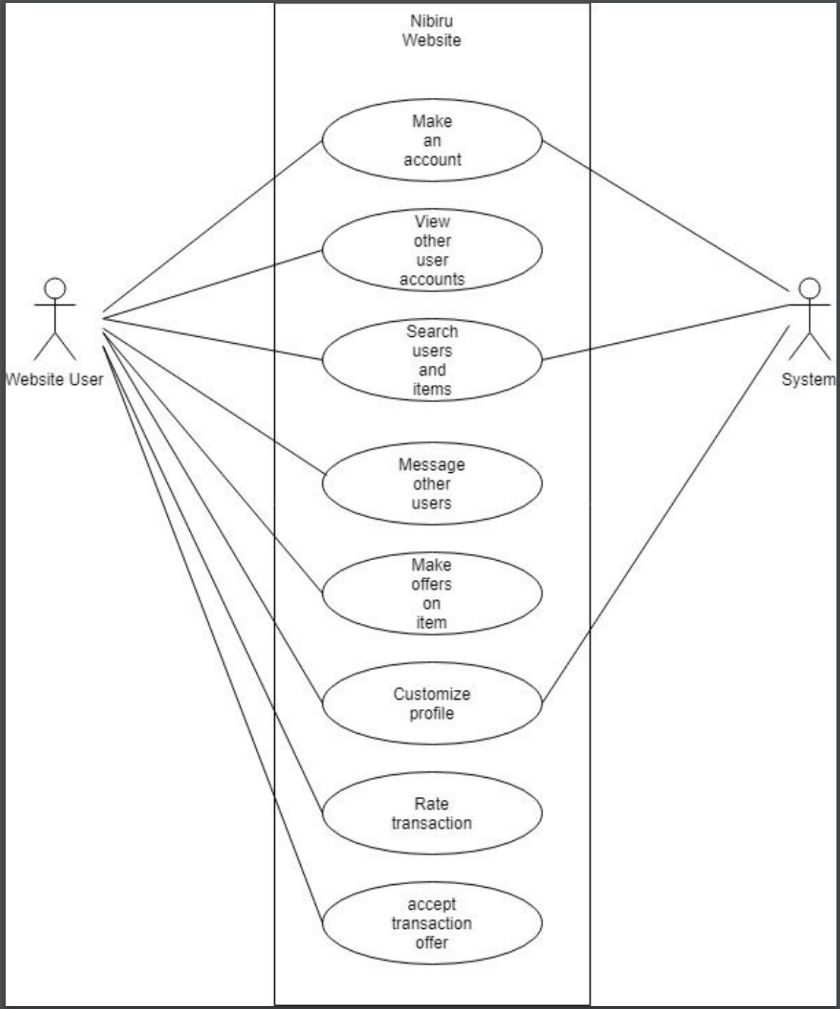

# Sequence Diagram

## Creating an Account

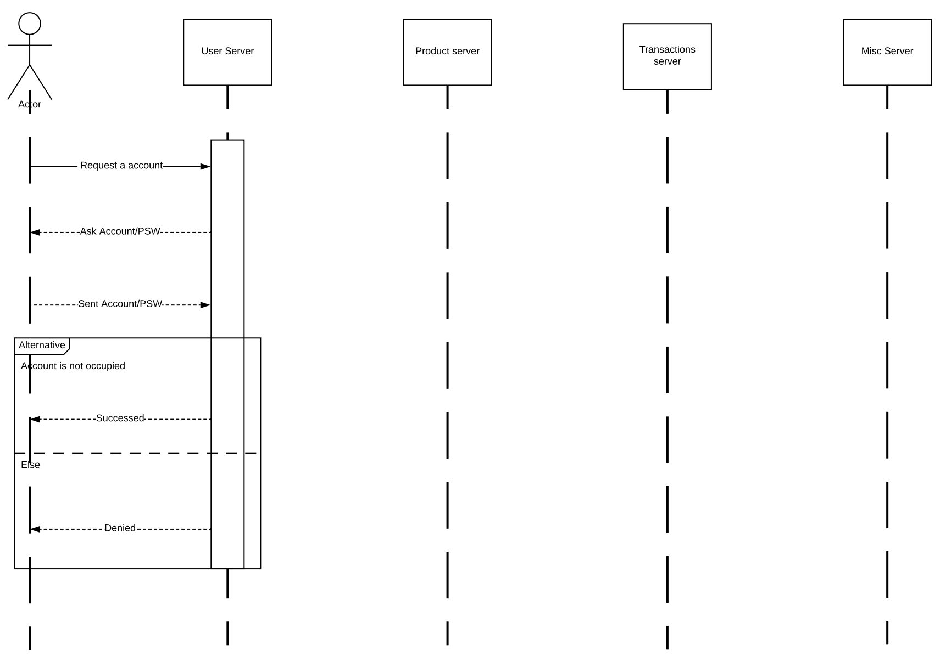

## Message Other User

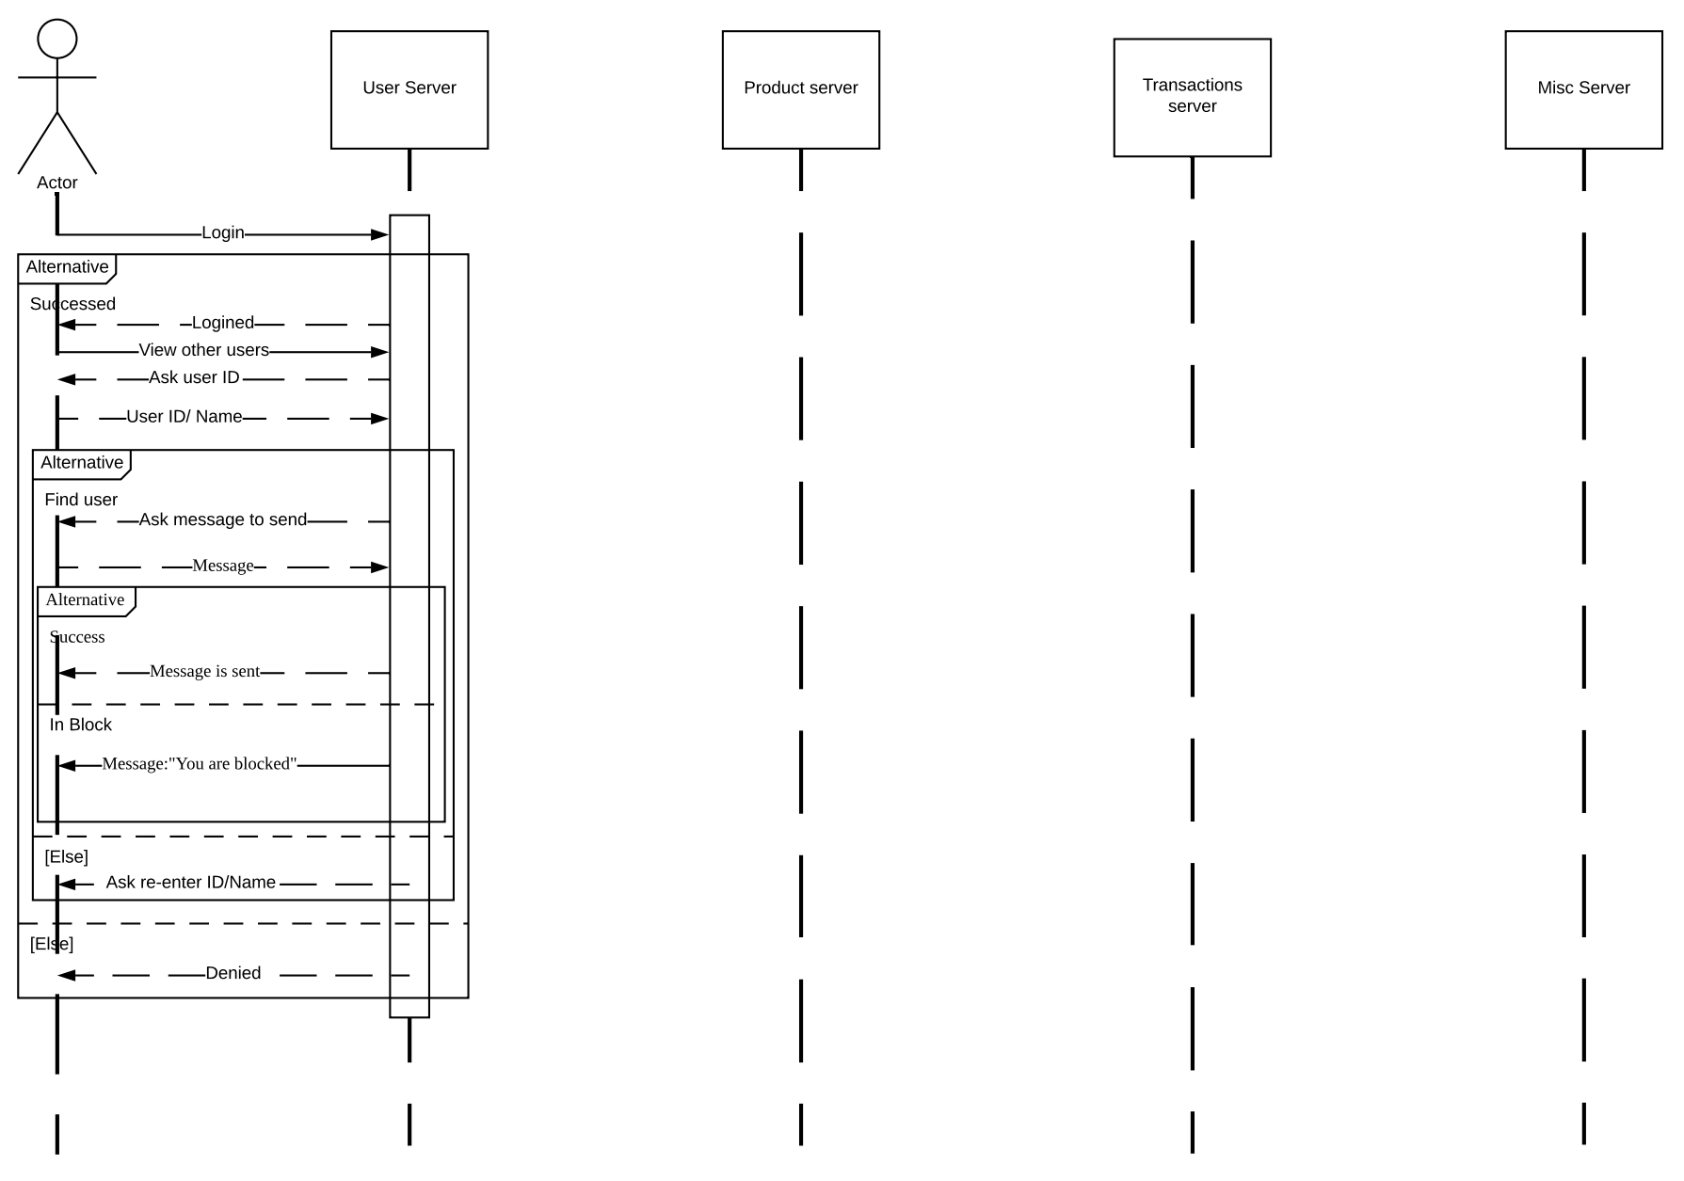

## Search Other Accounts for Items

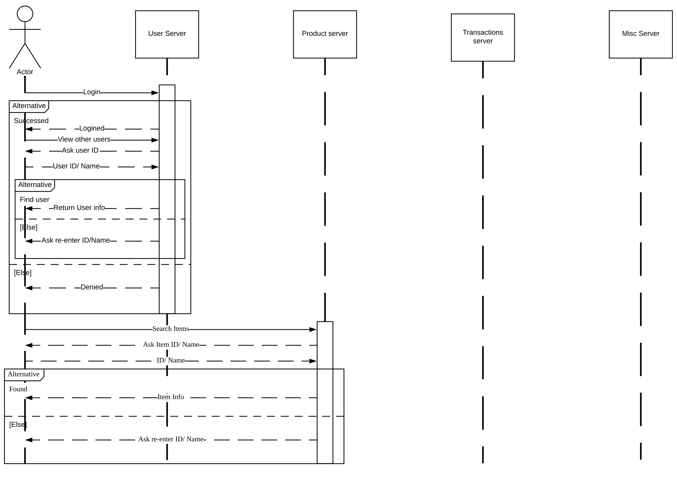

## View Other Users

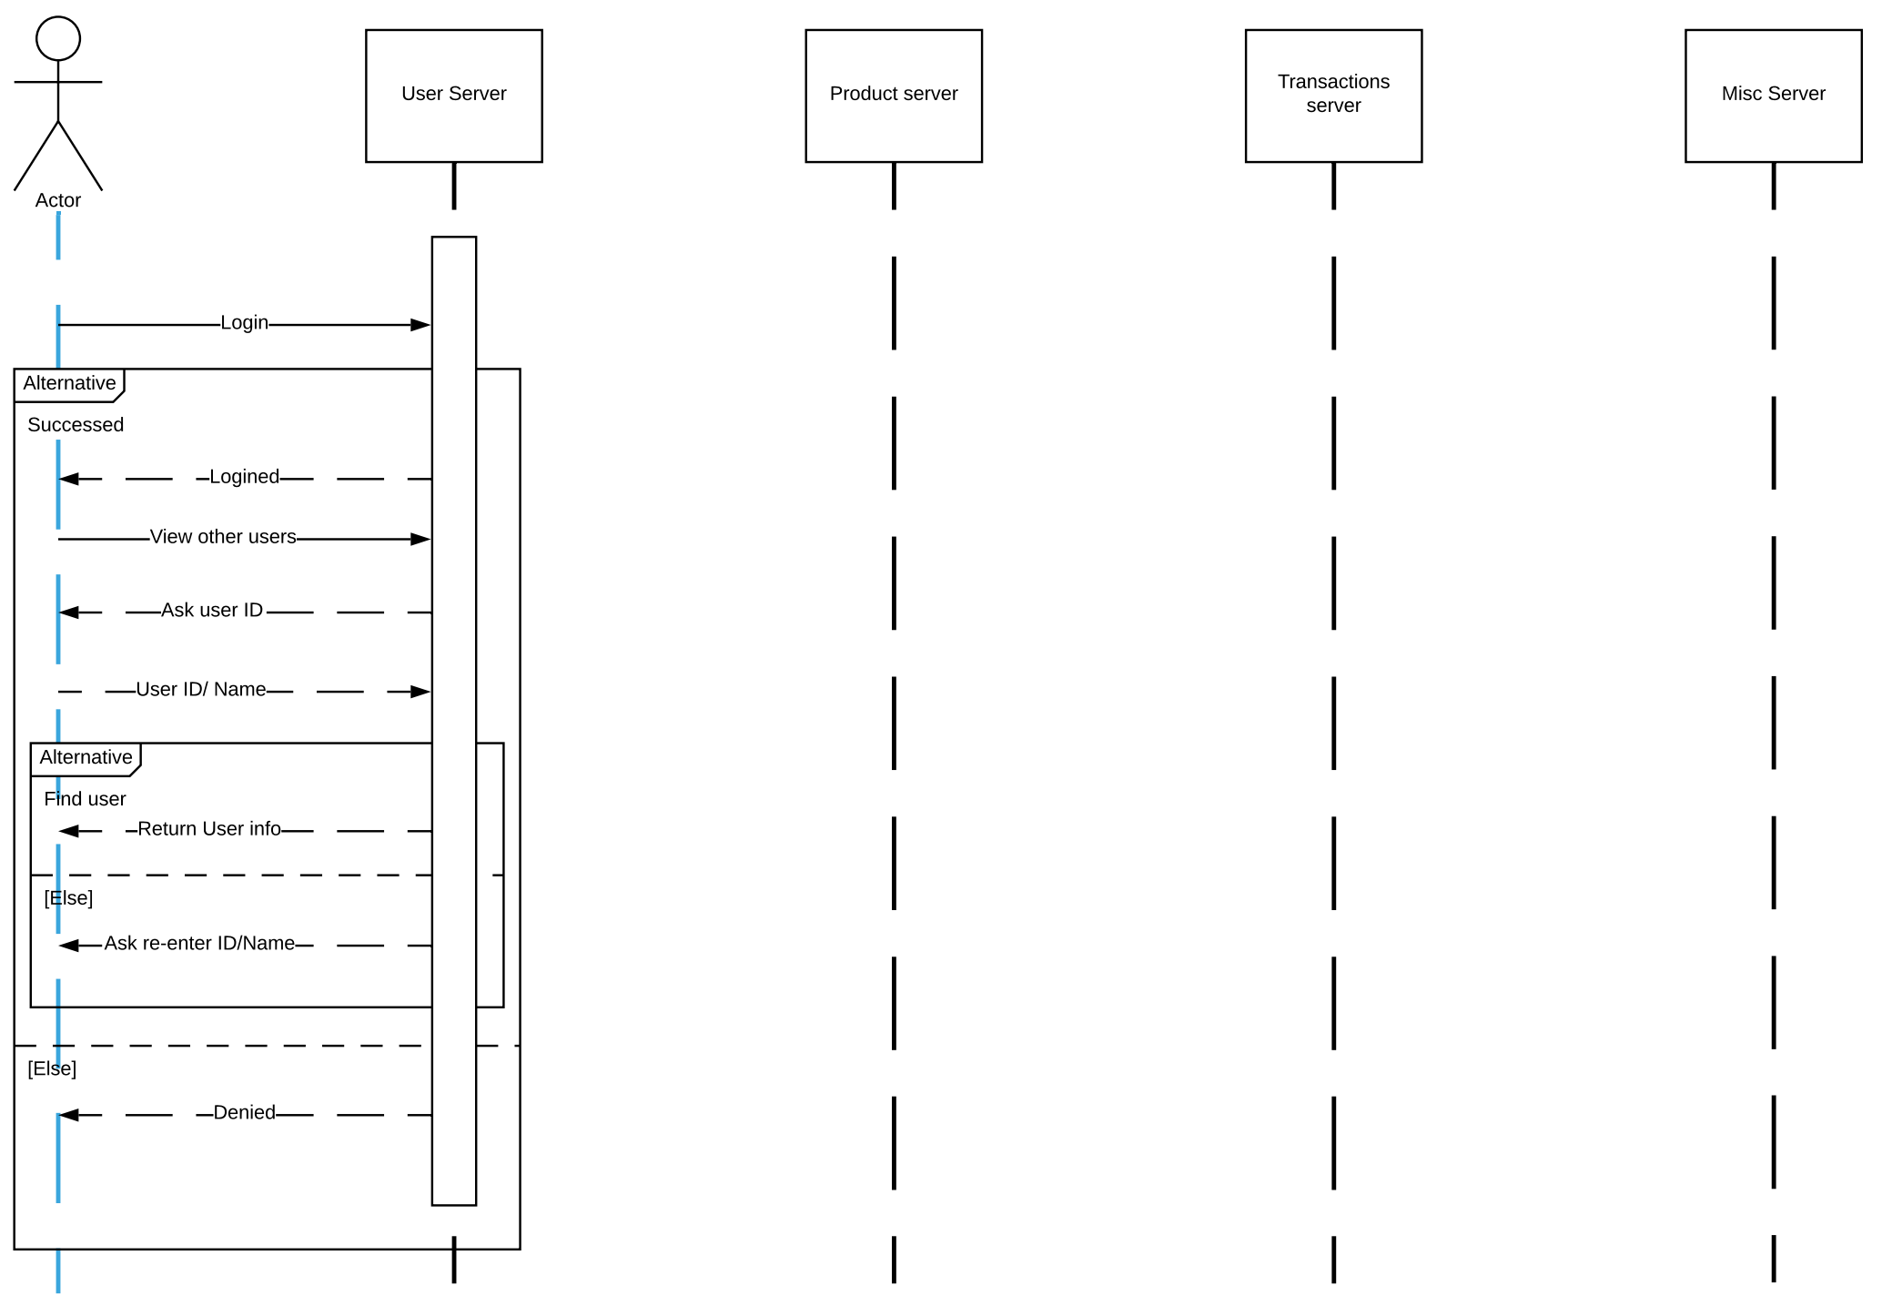

## Accept Transaction Offer

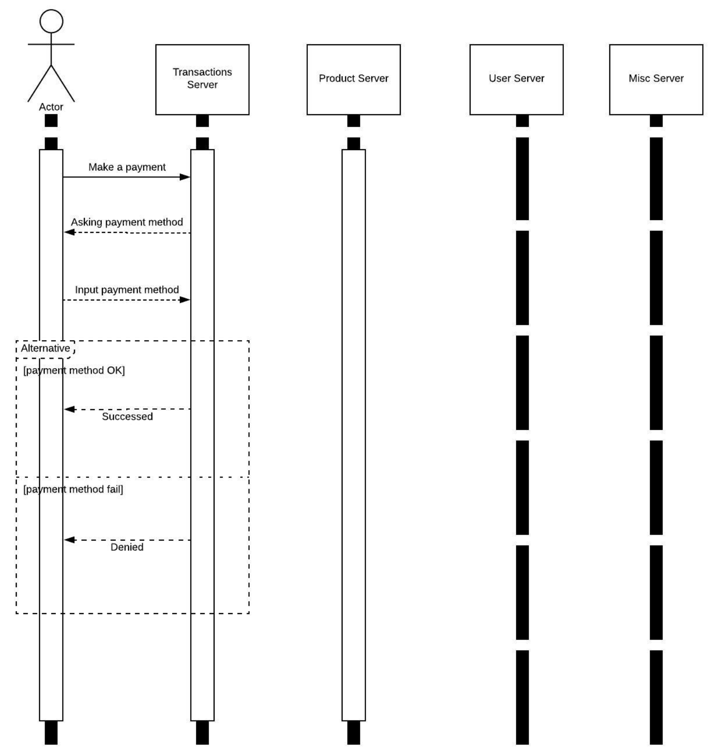

## Customize Profile

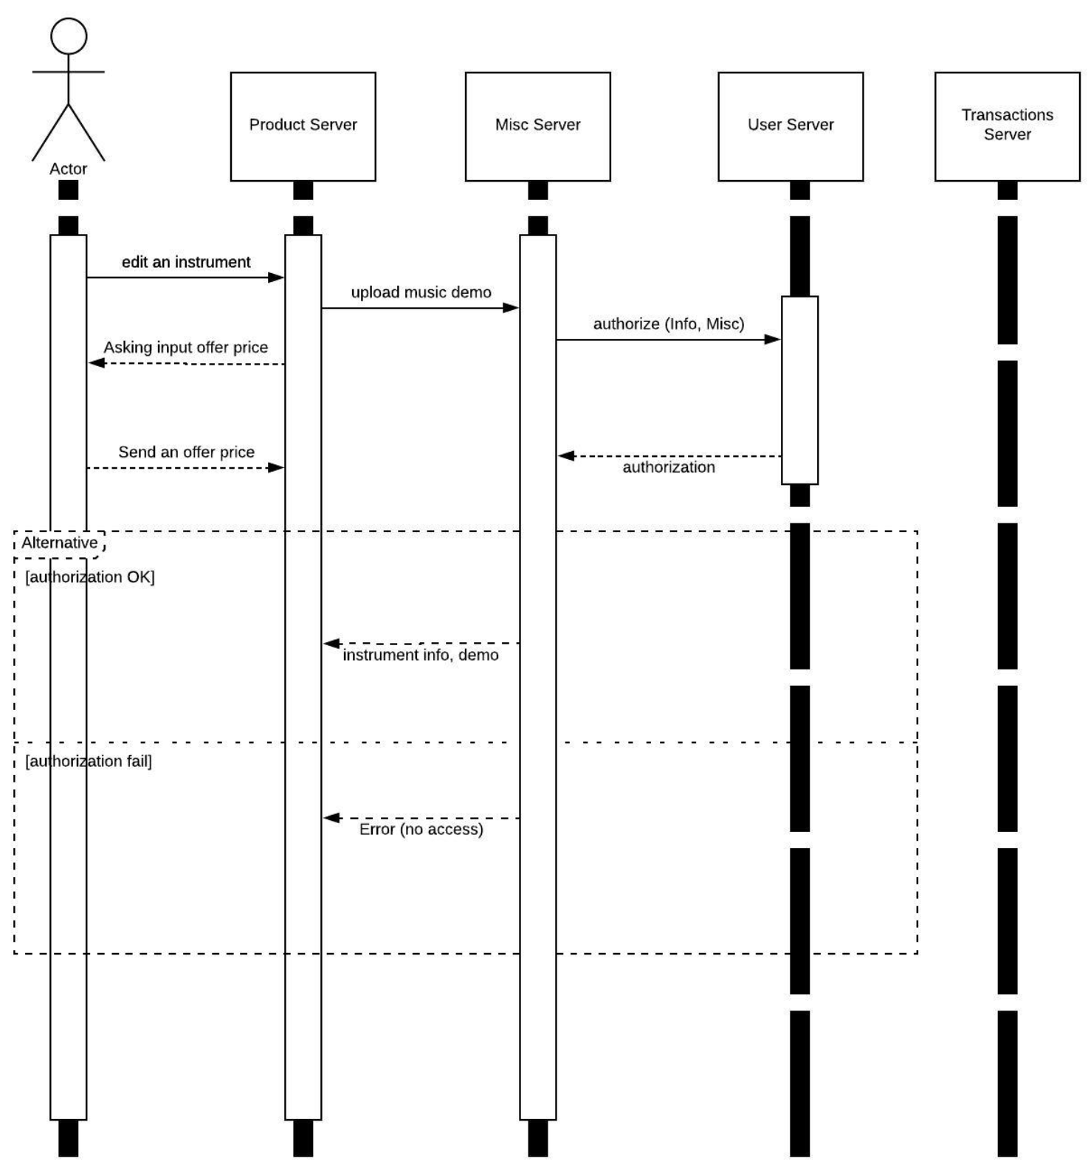

## Make an Offer On an Item

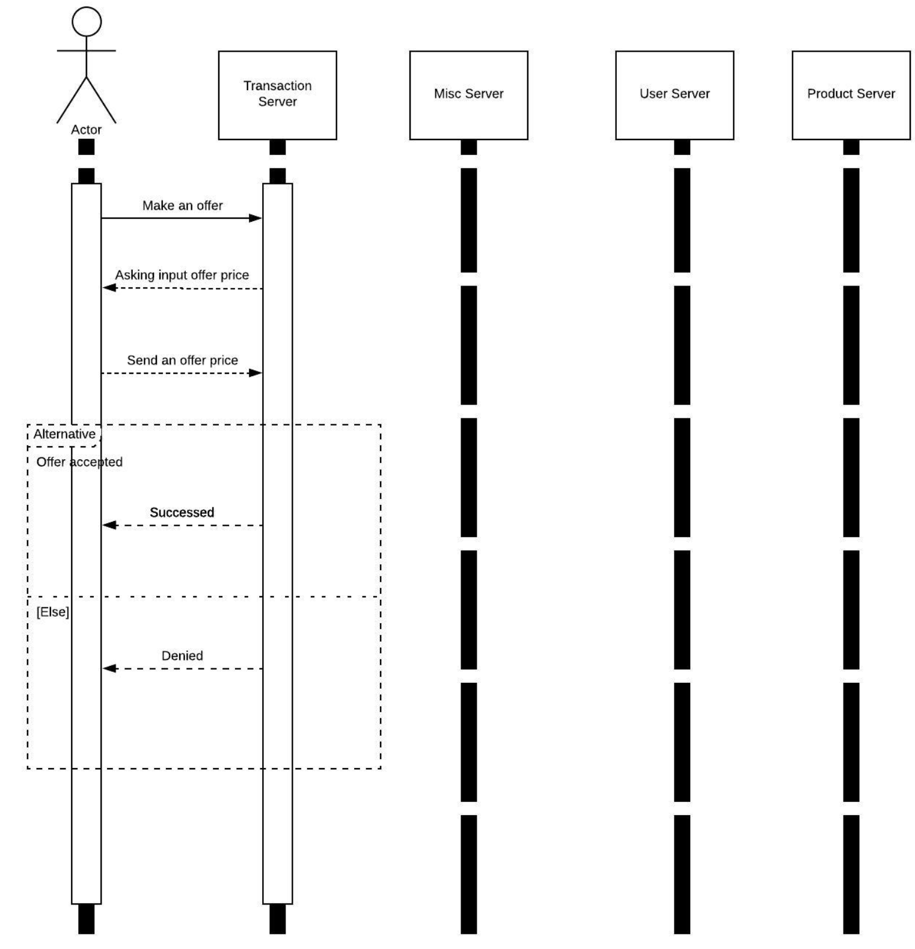

## Rate a Transaction

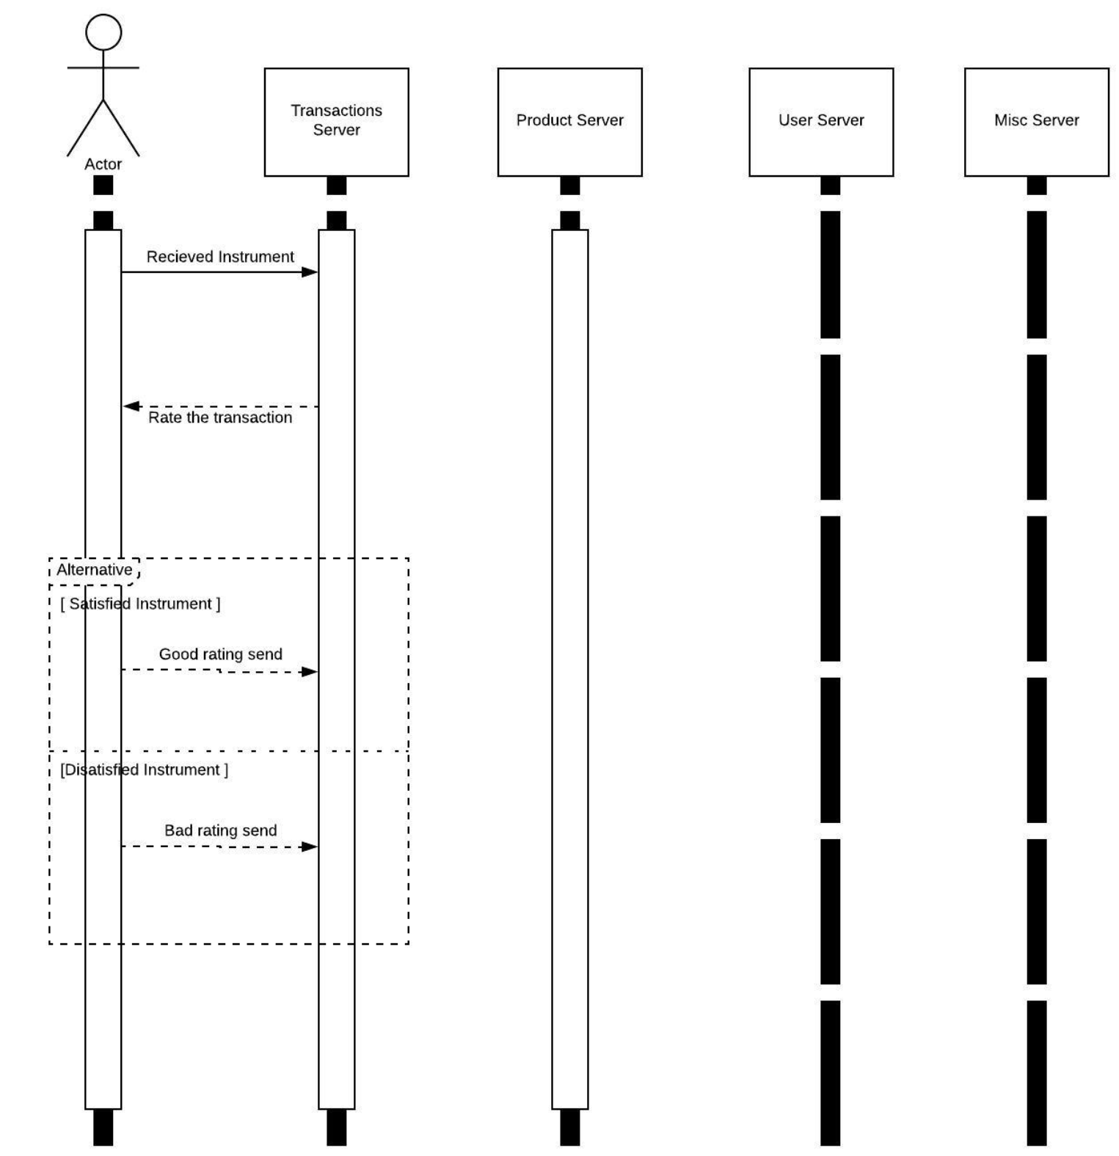

# Class Diagram

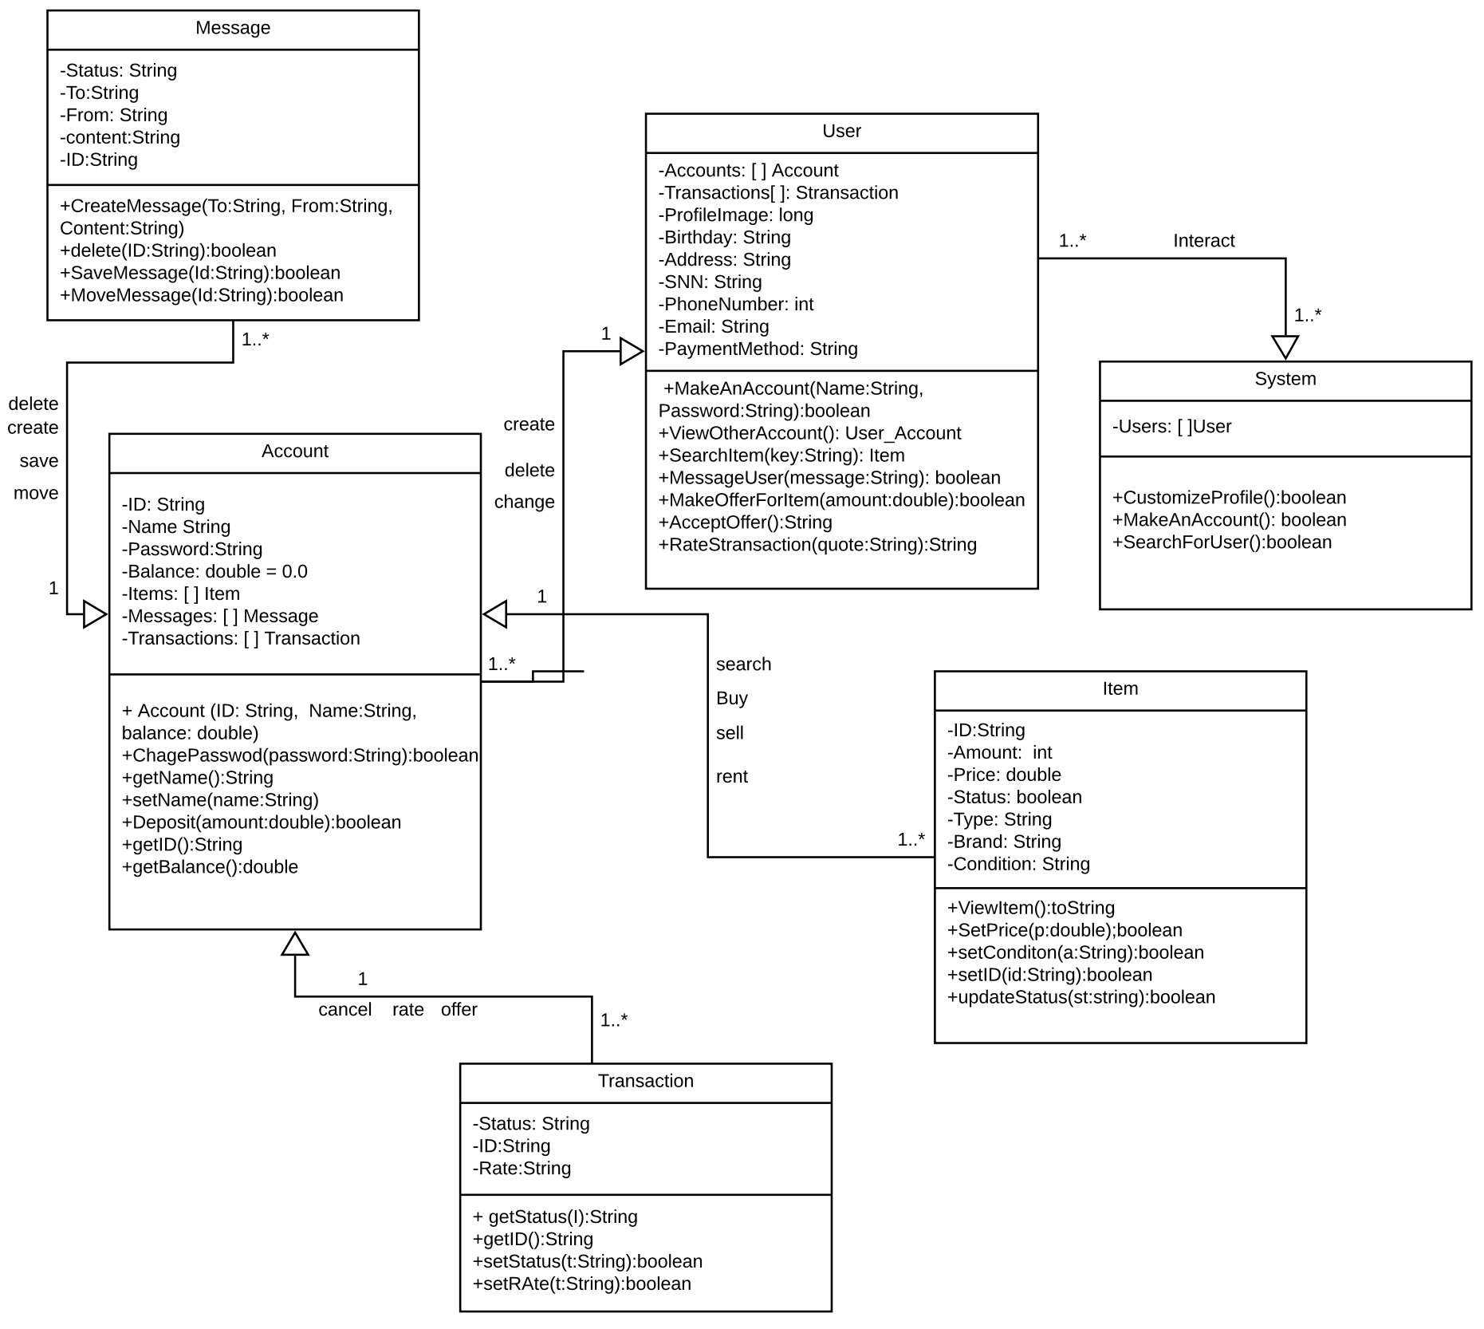

# Architectural Design

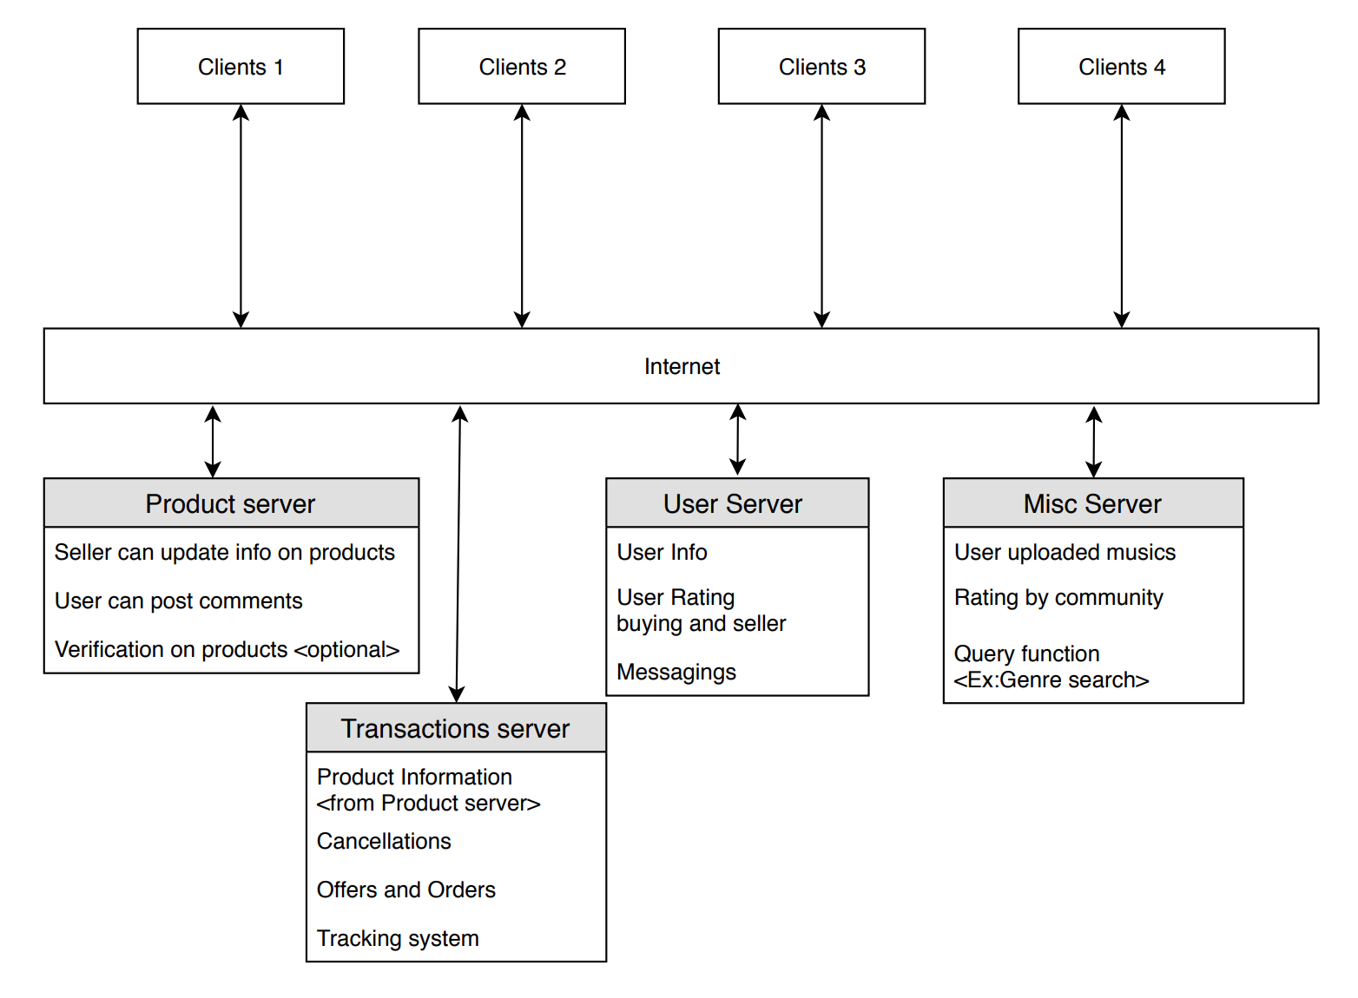

# Project Scheduling